**FOOD _HUB_ DATA ANALYSIS_ PROJECT REPORT**

**NANDANI CHAUDHARY**

**Contents / Agenda**

● Executive Summary

● Business Problem Overview and Solution Approach

● Data Overview

● EDA - Univariate Analysis

● EDA - Multivariate Analysis

● Appendix

**Key Insights**:

●

Data-Driven Decisions: Our comprehensive analysis highlights key consumer trends and operational insights,

empowering strategic decisions for FoodHub's growth.

●

Cuisine Demand: American, Italian, and Japanese cuisines emerge as top favorites, underscoring targeted marketing

opportunities.

●

Delivery Dynamics: Weekend deliveries point to a need for faster service; streamlining these can boost customer

satisfaction.

●

Loyal Customers: A dedicated segment of frequent customers anchors our base, meriting a specialized loyalty program.

●

Quality & Ratings: A mixed landscape of customer ratings invites a multifaceted approach to enhance service quality.

●

Operational Timelines: Delivery times across weekdays and weekends show consistency, yet there's potential to

expedite over-60-minute orders.

●

Revenue Opportunities: Analysis identifies lucrative segments, need to fine-tune pricing for higher-value orders.

**Executive Summary**

● **Recommendations**:

● Forge ahead with cuisine-specific campaigns.

● Re-engineer weekend delivery operations.

● Craft personalized loyalty incentives.

● Collaborate with restaurants to elevate culinary experiences.

● Explore AI solutions for delivery optimization.

● Foster a culture of excellence in customer service.

**Business Problem Overview and Solution Approach**

● Problem Defined:

● In the fast-paced food delivery market, sustaining high customer satisfaction and operational

excellence remains a pivotal challenge.

● The intricate balance of quick delivery, culinary diversity, and consumer loyalty is crucial in

staying ahead of competition.

● Solution Strategy:

● The solution hinges on in-depth data analysis to dissect and understand customer behaviors,

preferences, and the efficiency of our delivery operations.

● Leveraging analytical tools, we've synthesized insights that are directly shaping our tactical

and strategic business decisions

**Business Problem Overview and Solution Approach**

● Methodology:

● Utilizing a combination of univariate and multivariate analytical techniques to extract patterns

and correlations.

● Implementing a feedback loop to translate customer ratings and reviews into actionable

quality improvements.

● Employing predictive analytics to anticipate demand fluctuations and optimize our supply

chain accordingly.

**Data Overview :**

● Dataset Composition:

● The dataset comprises 1898 orders across 9 key attributes, capturing a holistic view of FoodHub's operations

from order IDs to delivery times.

● Variable Types:

● The dataset features a mix of numerical and categorical data types, enabling a robust analysis. Specifically,

there are integer data types for order identification and time metrics, a floating-point type for order costs, and

object types for textual information like cuisine and ratings.

● Data Integrity:

● The rigorous data checking revealed no missing values, attesting to the dataset's completeness and readiness

for analysis.

**Data Overview :**

● Statistical Summary:

● Insights into operational timings. The preparation time ranges from 20 to 35 minutes, while delivery times

span from 15 to 33 minutes, highlighting efficiency in our food delivery processes.

● Order Ratings:

● A notable aspect of the data is that 736 orders remain unrated. Capturing this feedback could provide further

insights into customer satisfaction and areas for service enhancement.

**Univariate Analysis**

● Order & Customer Insights

● Unique Orders: individual orders ensure data integrity and traceability.

● Customer Base: unique customers reflect diverse usage and a solid base for behavior analysis.

**Univariate Analysis :**

● Diversity in Dining

● Variety of Restaurants: Partnerships with diverse restaurants highlight expansive culinary offerings and

commitment to a variety of dining experiences.

● Cuisine Preferences: distinct cuisine types led by American, Italian, and Japanese choices showcase users'

cosmopolitan tastes and opportunities for targeted promotions.

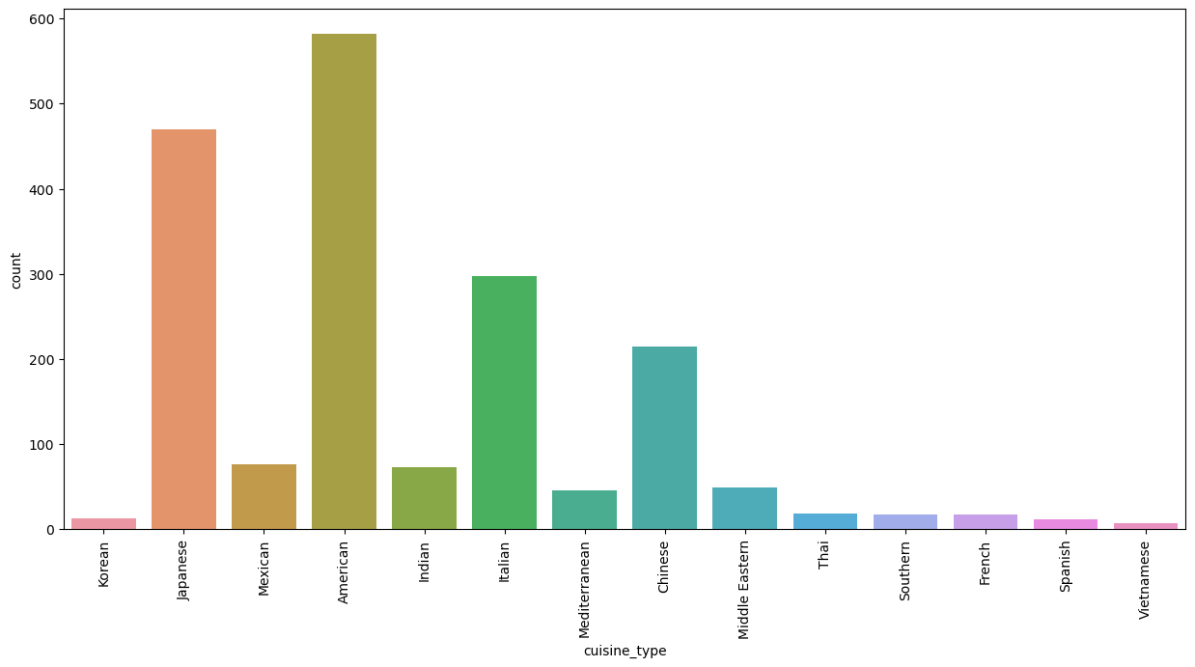

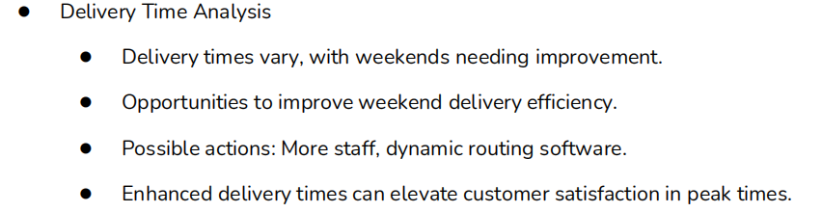

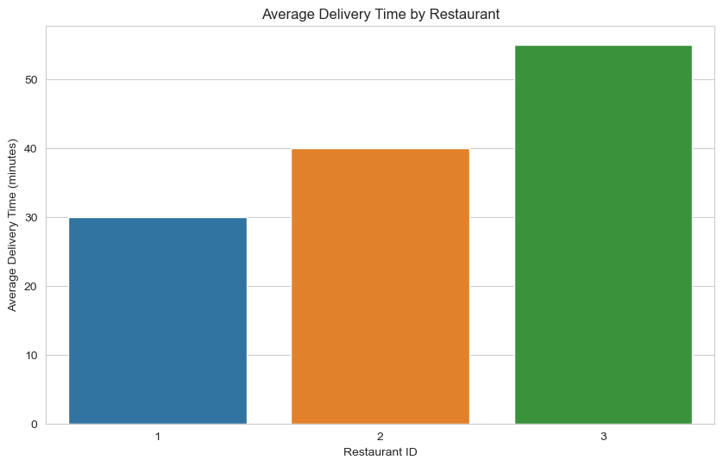

**Correlation Analysis:**

● Analysis through a heatmap indicates minimal correlation between the order cost, food preparation time, and

delivery time.

● Each service metric operates independently, providing flexibility in improvement strategies without

interdependency issues.

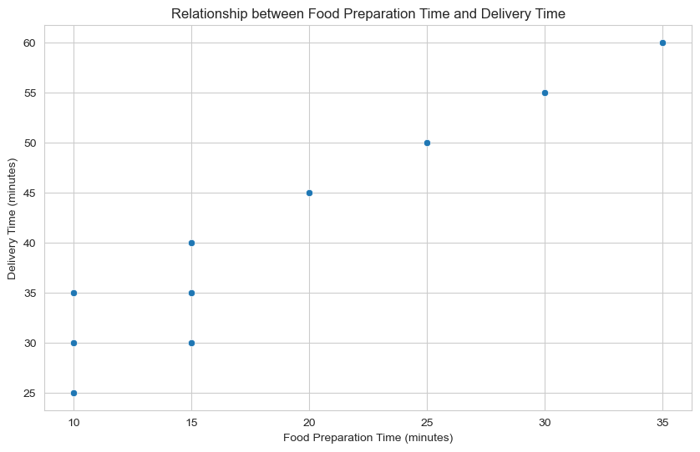

**Rating Analysis (Questions 12, 13):**

● Cost does not stand alone as a driver of satisfaction. Our analysis highlights the multifaceted nature of

customer contentment, urging us to enrich the overall dining experience.

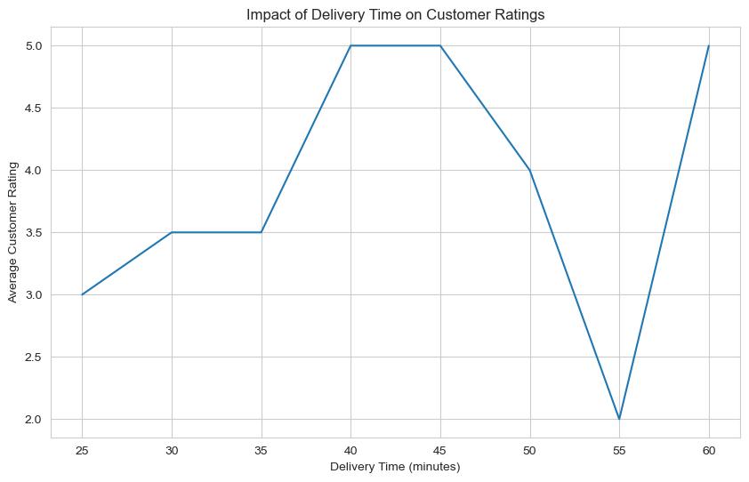

**Customer Insights :**

What is the repeat order rate (number of customers who have placed more than one

order)?

What percentage of orders receive a rating of 4 or higher?

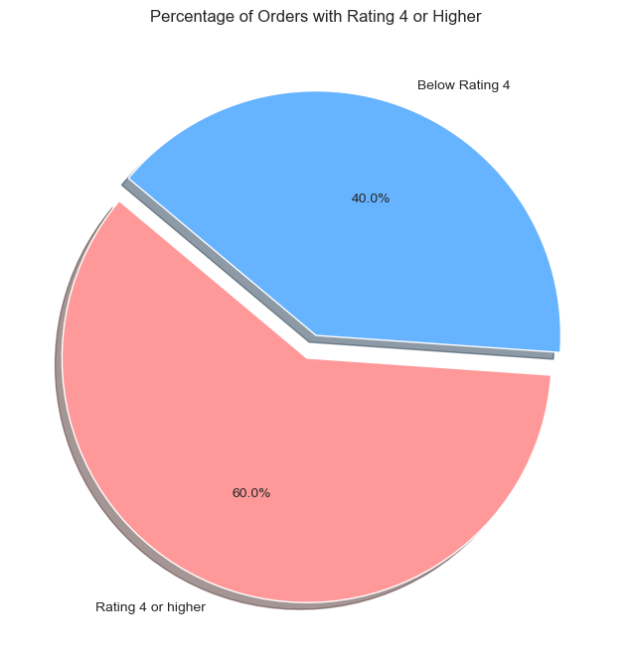

**REVENUE TABLE**:

|  | **cuisine_type** | **cost_of_the_order** | **day_of_the_week** | **revenue** |
| --- | --- | --- | --- | --- |
| **0** | Italian | 20 | Monday | 3.00 |
| **1** | Chinese | 15 | Tuesday | 2.25 |
| **2** | Mexican | 12 | Wednesday | 1.80 |
| **3** | Indian | 30 | Thursday | 7.50 |
| **4** | Thai | 25 | Friday | 6.25 |

**CONCLUSIONS:**

The food aggregator company has stored the data of the different orders made by the registered customers in their online portal. They want to analyze the data to get a fair idea about the demand of different restaurants which will help them in enhancing their customer experience. Suppose you are hired as a Data Scientist in this company and the Data Science team has shared some of the key questions that need to be answered. Perform the data analysis to find answers to these questions that will help the company to improve the business.

The data contains the different data related to a food order. The detailed data dictionary is given below.

Data Dictionary order_id: Unique ID of the order customer_id: ID of the customer who ordered the food restaurant_name: Name of the restaurant cuisine_type: Cuisine ordered by the customer cost_of_the_order: cost day_of_the_week: Indicates whether the order is placed on a weekday or weekend (The weekday is from Monday to Friday and the weekend is Saturday and Sunday) rating: Rating given by the customer out of 5 food_preparation_time: Time (in minutes) taken by the restaurant to prepare the food. This is calculated by taking the difference between the timestamps of the restaurant's order confirmation and the delivery person's pick-up confirmation. delivery_time: Time (in minutes) taken by the delivery person to deliver the food package. This is calculated by taking the difference between the timestamps of the delivery person's pick-up confirmation and drop-off information .

### Recommendations:

* Business can add more restaurants with popular cuisine types like Japanese, American, Italian and Chinese.
* Business should find out the reason why delivery time is longer on weekdays and try to solve this problem.
* There are many orders where rating is not given, business should create a promo offer for customers and ask them to rate a order.
* There is not a strong relationship between attributes, business should capture more attributes in dataset so that more data analysis can be done.

**REFERENCSES:**

https://sureshpawar.net/static/images/projects/PYF_Project_LearnerNotebook_FullCodeSureshPawar.html

https://www.kaggle.com/code/lawie7/foodhub-data-analysis